**LINUX Shell Programming Lab File**

**Name: Sauhard Vyas**

**Registration No. 199303048**

**Computer and Communication**

**Section – A**

**Batch – A2**

**INDEX**

|  |  |  |  |
| --- | --- | --- | --- |
| **S.No.** | **Program Name** | **Submission Date** | **Remarks** |
| 1. | Write a shell script program to display the following  HELLO WORLD, “Hello world”, Hello “world”, “hello “ World | 06/05/2022 |  |
| 2. | Write a shell script to evaluate arithmetic operations using three techniques  a) hardcoding the values in program b) input through keyboard  c) Bypassing values through command line arguments | 06/05/2022 |  |
| 3. | Write a shell script to calculate simple interest | 06/05/2022 |  |
| 4. | Write a shell script to Check whether number is Armstrong or not | 06/05/2022 |  |
| 5. | Write a shell script to find the factorial of the given number | 06/05/2022 |  |
| 6. | Write a shell script to Check whether the number is prime or not? | 06/05/2022 |  |
| 7. | Write a shell script to check whether the number is odd or even? | 06/05/2022 |  |
| 8. | Write a shell script to Check whether the year is leap-year or not? | 06/05/2022 |  |
| 9. | Write a shell script to Check whether the number is palindrome or not | 06/05/2022 |  |
| 10. | Write a shell script to Print Fibonacci series up to n terms? | 06/05/2022 |  |
| 11. | Write a shell script to print the reverse of the string | 06/05/2022 |  |
| 12. | Write a Shell script Program to search whether element is present is in the list or not. | 06/05/2022 |  |
| 13. | Write a Shell script program to check whether given file is a directory or not. | 06/05/2022 |  |
| 14. | Write a Shell script program to count number of files in a Directory. | 06/05/2022 |  |
| 15. | Write a shell script program to display the process attributes. | 06/05/2022 |  |
| 16. | Write a shell script to change the priority of processes. | 06/05/2022 |  |
| 17. | Write a shell script to do arithmetic operations using functions in shell programming? | 06/05/2022 |  |
| 18 | Write a shell script to read file name from user and display the permissions of the file? | 06/05/2022 |  |
| 19. | Write a shell script to print last 5 characters of a variable? | 06/05/2022 |  |
| 20. | Write a shell Script to determine largest among three integer number. | 06/05/2022 |  |
| 21. | Write a shell script to do:  (i). display list of directory contents (ii). Name of current directory  (iii). Who is logged on  (iv). Long listing of  directory contents according to choice of user. | 06/05/2022 |  |
| 22. | Write a program to send back a process from foreground. | 06/05/2022 |  |
| 23. | Write a program to retrieve a process from background. | 06/05/2022 |  |
| 24. | To check whether a file is a directory, file or executable. | 06/05/2022 |  |

Q1. Write a shell script program to display the following

HELLO WORLD, “Hello world”, Hello “world”, “hello “World

**#!/bin/bash**

**echo "HELLO WORLD"**

**echo "\"Hello World\""**

**echo "Hello \"world\""**

**echo "\"hello \" World"**

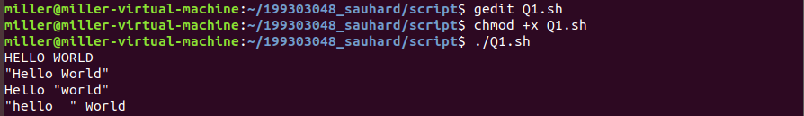

Q2. Write a shell script to evaluate arithmetic operations using three techniques

a) hardcoding the values in program

**#!/bin/bash**

**a=6**

**b=4**

**expr $a + $b**

**expr $a - $b**

**expr $a \* $b**

**expr $a / $b**

**expr $a % $b**

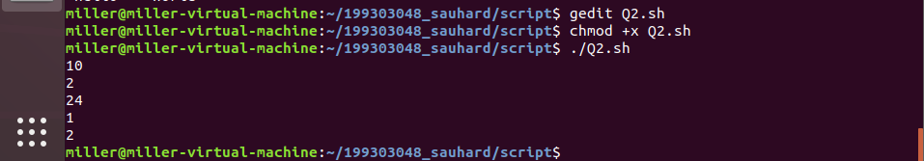

b) input through keyboard

**#!/bin/bash**

**read a b**

**expr $a + $b**

**expr $a - $b**

**expr $a \* $b**

**expr $a / $b**

**expr $a % $b**

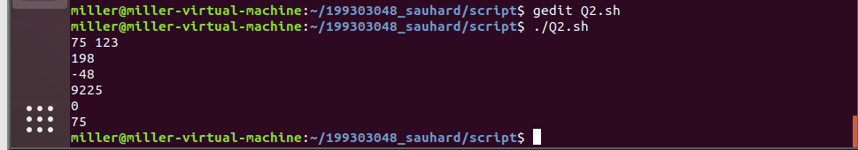

c) Bypassing values through command line arguments

**#!/bin/bash**

**a=$1**

**b=$2**

**expr $a + $b**

**expr $a - $b**

**expr $a \* $b**

**expr $a / $b**

**expr $a % $b**

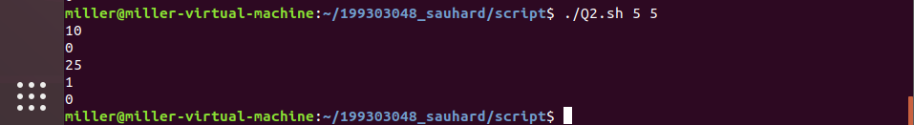

3. Write a shell script to calculate simple interest.

**#!/bin/bash**

**echo " Enter the principle value: "**

**read p**

**echo " Enter the rate of interest:"**

**read r**

**echo " Enter the time period:"**

**read t**

**si=`expr $p \* $t \* $r / 100`**

**echo " The simple interest is "**

**echo $si**

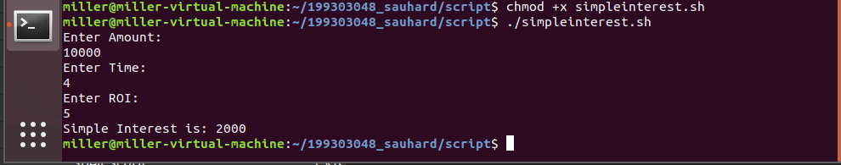

4.Write a shell script to Check whether number is Armstrong or not.

**#!/bin/bash**

**num=$1**

**sum=0**

**for (( i = 0; i < ${#num}; i++));**

**do**

**digit=${num:$i:1}**

**sum=$(($sum + ($digit * $digit * $digit)))**

**done**

**if [ "$sum" = "$num" ]; then**

**echo "Armstrong"**

**else**

**echo "Not Armstrong"**

**fi**

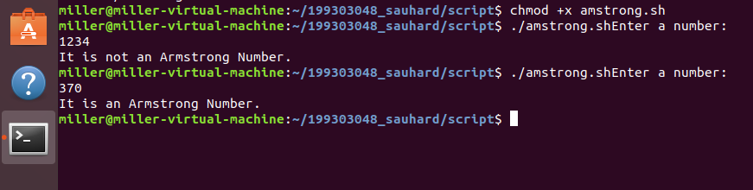

5.Write a shell script to find the factorial of the given number.

**#!/bin/bash**

**num=$1**

**sum=1**

**for i in $(seq 1 $num);**

**do**

**sum=$(( $sum * $i ))**

**done**

**echo $sum**

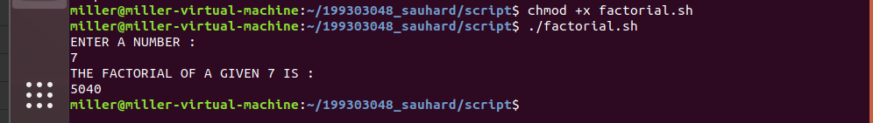

6. Write a shell script to Check whether the number is prime or not?

**#!/bin/bash**

**num=$1**

**for (( i = 2; i < $num; i++ ));**

**do**

**rem=$(( $num % $i ))**

**if [ "$rem" = "0" ];**

**then**

**echo "Not Prime"**

**exit 0**

**fi**

**done**

**echo "Prime"**

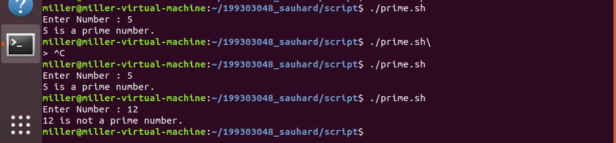

7. Write a shell script to check whether the number is odd or even?

**#!/bin/bash**

**num=$1**

**rem=$(( $num % 2 ))**

**if [ "$rem" = "0" ];**

**then**

**echo "Even"**

**else**

**echo "Odd"**

**fi**

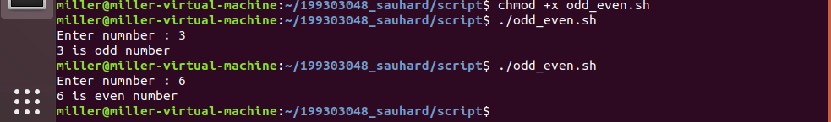

8.Write a shell script to Check whether the year is leap-year or not?

**#!/bin/bash**

**year=$1**

**# checking if it is divisible by 400**

**div_400=$(( $year % 400 ))**

**# checking if it is a multiple of 4 and not a multiple of 100**

**div_4=$(( $year % 4 ))**

**div_100=$(($year % 100 ))**

**if [ "$div_400" = "0" ];**

**then**

**echo "Leap Year"**

**exit 0**

**fi**

**if [ "$div_4" = "0" ];**

**then**

**if [ "$div_100" != "0" ];**

**then**

**echo "Leap Year"**

**exit 0**

**fi**

**fi**

**echo "Not a Leap Year"**

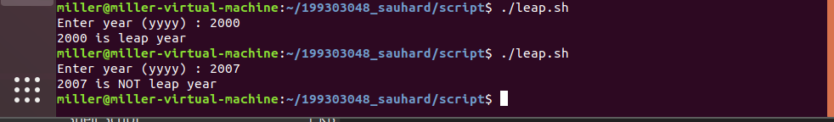

9. Write a shell script to Check whether the number is palindrome or not.

**#!/bin/bash**

**num=$1**

**reversed=$(echo $num | rev)**

**if [ "$num" = "$reversed" ];**

**then**

**echo "Palindrome"**

**else**

**echo "Not Palindrome"**

**fi**

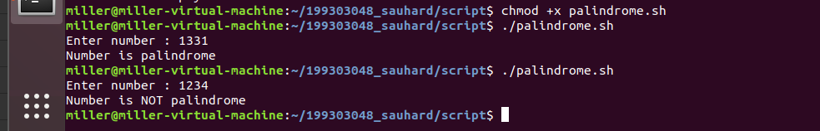

10. Write a shell script to Print Fibonacci series up to n terms?

**#!/bin/bash**

**count=$1**

**a=0**

**b=1**

**c=$(( $a + $b ))**

**for (( i = 0; i < $count; i++ ));**

**do**

**echo -n "$a "**

**a=$b**

**b=$c**

**c=$(( $a + $b ))**

**done**

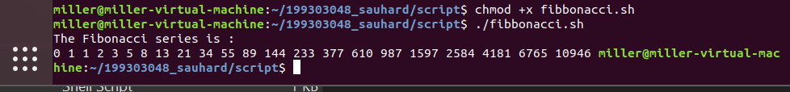

11. Write a shell script to print the reverse of the string

**#!/bin/bash**

**echo $1 | rev**

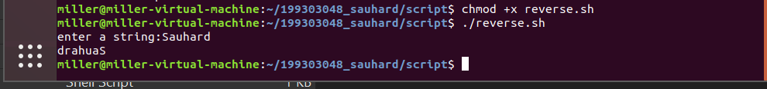

12. Write a Shell script Program to search whether element is present is in the list or not.

**#!/bin/bash**

**echo "Enter value to search"**

**read item**

**echo "Enter list of values"**

**read list**

**for i in $list;**

**do**

**if [ "$item" = "$i" ];**

**then**

**echo "Item Found!"**

**exit 0**

**fi**

**done**

**echo "Item not found!"**

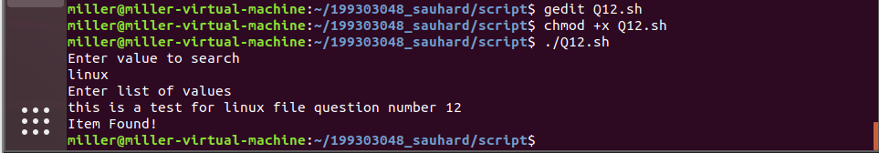

13. Write a Shell script program to check whether given file is a directory or not.

**#!/bin/bash**

**inp=$1**

**if [[ -d $inp ]];**

**then**

**echo "Directory"**

**elif [[ -f $inp ]];**

**then**

**echo "File"**

**else**

**echo "Invalid!"**

**fi**

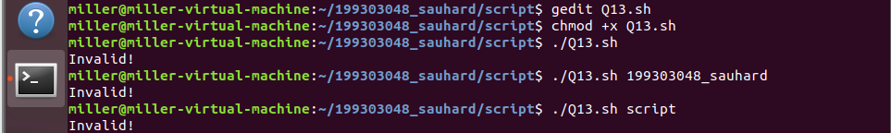

14. Write a Shell script program to count number of files in a Directory.

**#!/bin/bash**

**dir=$1**

**count=$(find $1 -maxdepth 1 -not -type d | wc -l)**

**echo $count**

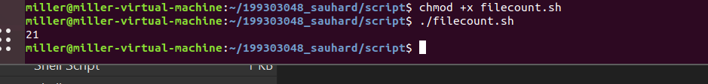

15.Write a shell script program to display the process attributes.

**#!/bin/bash**

**ps -p $1 -lf**

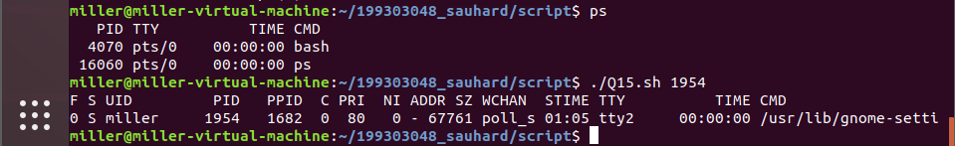

16. Write a shell script to change the priority of processes.

**#!/bin/bash**

**renice -n $1 -p $2**

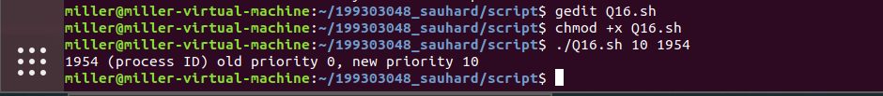

17. Write a shell script to do arithmetic operations using functions in shell programming?

**#!/bin/bash**

**add() {**

**echo $(( $1 + $2 ))**

**}**

**sub() {**

**echo $(( $1 - $2 ))**

**}**

**mul() {**

**echo $(( $1 * $2 ))**

**}**

**div() {**

**echo $(( $1 / $2 ))**

**}**

**mod() {**

**echo $(( $1 % $2 ))**

**}**

**echo "Enter 2 numbers"**

**read a b**

**add $a $b**

**sub $a $b**

**mul $a $b**

**div $a $b**

**mod $a $b**

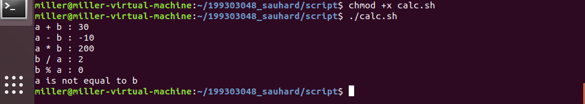

18. Write a shell script to read file name from user and display the permissions of the file?

**#!/bin/bash**

**echo "Enter file name"**

**read file**

**ls -l $file | cut -d' ' -f 1**

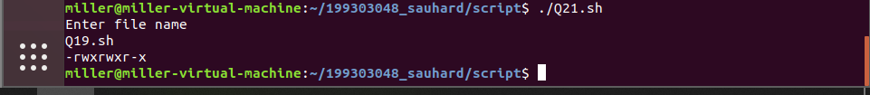

19. Write a shell script to print last 5 characters of a variable?

**#!/bin/bash**

**echo "Input string"**

**read var**

**len=${#var}**

**if [ $len -lt 5 ];**

**then**

**echo "Input string has length less than 5"**

**else**

**echo ${var: -5}**

**fi**

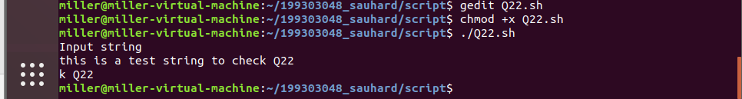

20. Write a shell Script to determine largest among three integer number.

**#!/bin/bash**

**a=$1**

**b=$2**

**c=$3**

**largest=$a**

**if [ $a -gt $b ];**

**then**

**largest=$a**

**else**

**largest=$b**

**fi**

**if [ $c -gt $largest ];**

**then**

**largest=$c**

**fi**

**echo $largest**

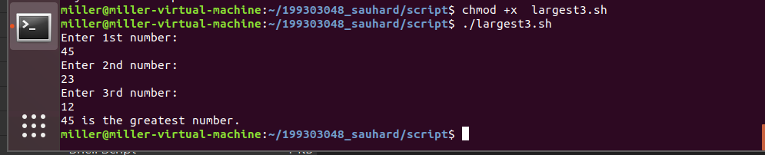

21. Write a shell script to do:

(i). display list of directory contents

(ii). Name of current directory

(iii). Who is logged on

(iv). Long listing of directory contents according to choice of user.

**#!/bin/bash**

**echo "List of directory contents"**

**ls**

**echo "name of current directory"**

**pwd**

**echo "Who is logged in"**

**who**

**echo "Long lisiting of directory"**

**ls -al**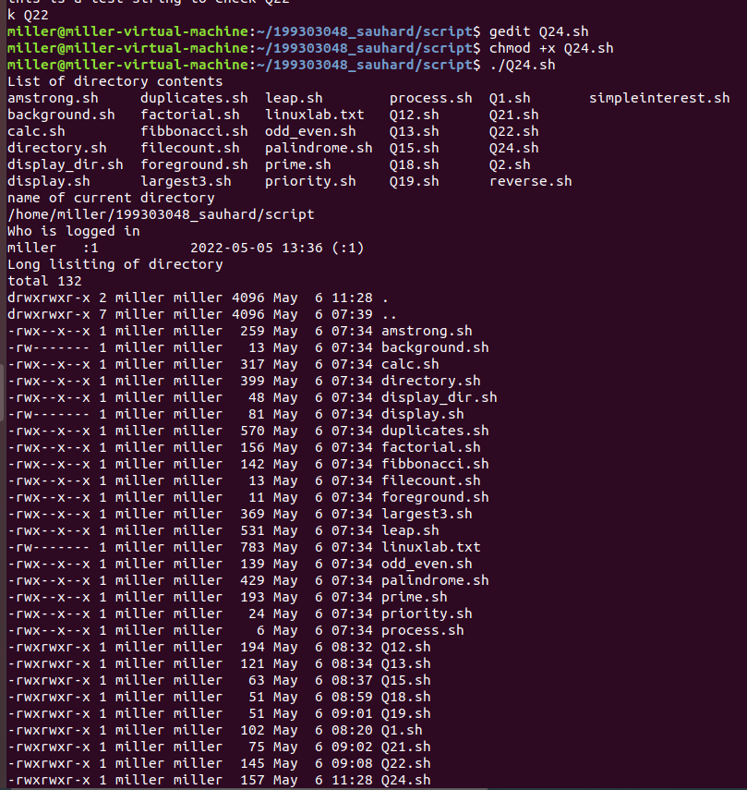

22. Write a program to send back a process from foreground.

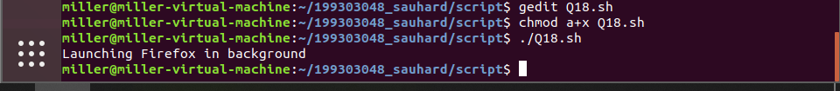

23. Write a program to retrieve a process from background.

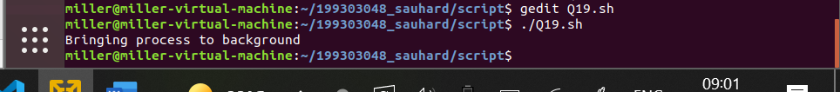

24. Write a Shell script program to check whether given is a file or a directory or executable.

**#!/bin/bash**

**inp=$1**

**if [[ -d $inp ]];**

**then**

**echo "Directory"**

**elif [[ -f $inp ]];**

**then**

**echo "File"**

**else**

**echo "Invalid!"**

**fi**

